World Senior Professional Bull Riders Association
WSPBR World Finals 2026
Hopkins County Regional Civic Center
Sulphur Springs, Texas
November 12-14 2026

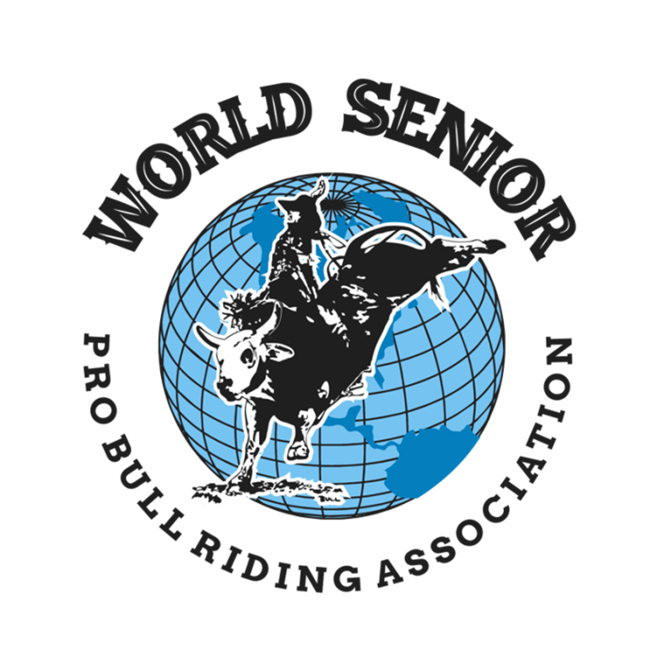

Mission Statement

The WSPBR is a non-profit whose mission is to keep the western heritage alive by allowing bull riders to
live out their dreams by continuing in the sport they love. We strive to emulate integrity, sportsmanship, and accountability to upcoming riders.

History of the WSPBR

Before the inaugural season in 2009, three men had a passion of continuing their rodeo careers beyond their prime. As most know, being in your mid 30’s is considered “over the hill” for a bull rider. But, these men felt that like themselves, there were other riders of age that still had a passion and drive for the sport. The WSPBR was officially born.

Robert Long, Morgan Saunders and Troy Moseley are the Founding Fathers, of what is now considered, the longest running and most competitive senior bull riding association in the world. Thus the name, World Senior Professional Bull Riders Association.

With 30+ events per year and over 300 members, the WSPBR attracts bull riders from all over the continental United States and beyond those borders. Membership cards are scattered from Texas, Oklahoma, Louisiana, New Mexico, Kansas, Missouri, Arkansas, Iowa, Indiana, Virginia, and Colorado. As well as Mexico, Guatemala, Brazil, Canada and Australia.

All riders are competing for valuable points throughout the year in order to make the coveted World Finals. Membership is open to anyone 35 and older and there are currently four different age groups to compete in, 35-42, 43-49, 50-57, and 58 and over. All points lead to the title of World Champion, one in each age group. The dreams of these three individuals have kept the hopes and dreams alive of hundreds of bull riders across the land. Their core values of faith, family and friends have been instilled in every member, past and present, and will continue to grow and flourish for years to come.

Sponsorship Opportunities for the WSPBR World Finals

Diamond Sponsor - $5000

• Headline Sponsor for the WSPBR World Finals
• Company logo/name advertised on various banners around the arena
• Company logo/name advertised on contestant/family jackets
• Company logo/name listed on all event advertisements, website & social media
• Company logo/name advertised on WSPBR Finals t-shirts
• Receive a WSPBR Sponsor Jacket
• Receive a WSPBR Championship buckle with company logo/name
• Receive 6 free tickets to all 3 performances
• Exclusive meet and greet with contestants and directors

Platinum Sponsor - $3000

• Bull Fighter Sponsor (one bull fighter) for the WSPBR World Finals (Only 3 Available)
• Company logo/name advertised on contestant/family jackets and Bull Fighter Jersey
• Company logo/name listed on all event advertisements, website & social media
• Company logo/name advertised on WSPBR Finals t-shirts
• Company logo/name advertised on a banner in the arena
• Receive a WSPBR Sponsor Jacket
• Receive 4 free tickets to all 3 performances

Gold Sponsor - $2000

• Chute Gate Sponsor for the WSPBR World Finals (Only 6 Available)
• Company logo/name advertised on contestant/family jackets
• Company logo/name listed on all event advertisements, website & social media
• Company logo/name advertised on WSPBR Finals t-shirts
• Company logo/name advertised on bucking chute gate
• Receive a WSPBR Championship buckle with company logo/name
• Receive 4 free tickets for all 3 performances

Silver Sponsor - $1500

• Buckle Sponsor for the WSPBR World Finals
• Company logo/name listed on all event advertisements, website & social media
• Company logo/name advertised on WSPBR Finals t-shirts
• Company logo/name advertised on a banner in the arena
• Receive a WSPBR Championship buckle with company logo/name
• Receive 2 free tickets to all 3 performances

Bronze Sponsor - $1000

• Finals Sponsor for the WSPBR World Finals
• Company logo/name listed on all event advertisements, website & social media
• Company logo/name advertised on WSPBR Finals t-shirts
• Company logo/name advertised on a banner in the arena
• Receive a WSPBR Finals t-shirt
• Receive 2 free tickets to all 3 performances

Partner Sponsor - $500

• Partner Sponsor for the WSPBR World Finals
• Company logo/name listed on all event advertisements, website & social media
• Company logo/name advertised on a banner in the arena

Sponsorship Agreement Form

Sponsorship Level – Circle One

Diamond Sponsor - $5000
Platinum Sponsor - $3000
Gold Sponsor - $2000
Silver Sponsor - $1500
Bronze Sponsor - $1000
Partner Sponsor - $500

Company Name______________________________________________________
Company Contact____________________________________________________
Address____________________________________________________________
Phone #____________________ Email Address____________________________

Please provide information and logo (pdf format) for advertisement purposes to:

Chris Kirby – twisterkirby.wspbr@gmail.com

Make checks payable and mail to: WSPBR, PO Box 1212 Burleson, TX 76097
Once Sponsorship Form and check are received, we will issue the 501c3 donation receipt

For more information please contact the following:
Vice President: Chris Kirby – 817-819-9129 - email: twisterkirby.wspbr@gmail.com
Sponsorship Coordinator: Valarie Long – 254-784-0045 – email: valarielong.wspbr@gmail.com
President: Gary Johns - 817-458-6567
Secretary: Cathey Saunders - 817-312-2091

